07th March 2017

**YOKOHAMA to Launch European Sales of Crossover SUV/CUV On-Road Tyre “BluEarth RV-02”**

YOKOHAMA announced today that it will expand marketing of its “BluEarth RV-02” tyres, currently sold in Japan and Asia, to Europe, gradually rolling out the tyre across the continent from this summer. In Europe, the “BluEarth RV-02” tyres will be available in 35 sizes, ranging from 245/35R20 95W XL to 195/65R15 91H. The tyres have secured the highest grade “A” ranking for wet grip performance under Europe’s tire labeling system. They also have “C” grade for rolling resistance.   
  
The market of crossover SUVs and minivans in Europe is dramatically growing and leading to diversification in driver demands on tyre performance. European drivers are, in particular, demanding tyres that deliver better on-road performance such as wet grip and quietness.   
  
In addition to the basic concept of a fuel-efficient tyre that performs well in wet condition, the “BluEarth RV-02” was developed with a view toward suppressing the tendency of tall and heavy vehicles to shake, resulting in uneven tyre wear, while also delivering a superior quietness. The tyres provide drivers of tall and heavy vehicles, such as minivans and SUVs, with a greater sense of stability when driving on rainy days. They also contribute to an unusually quiet ride that facilitates conversation not only between the driver and a seat passenger but also with passengers in the second and third seats, often a challenge in box-type vehicles in which noise tends to reverberate throughout the cabin.  
  
“BluEarth” is YOKOHAMA’s “environmentally, human and socially friendly” global tyre brand realizing not only excellent environmental performance, but reducing specific burdens on drivers, passengers and surrounding living environments – friendly performance. The “BluEarth RV-02” is one of the latest additions to YOKOHAMA’s “BluEarth” lineup in Europe, which already includes the high-performance and fuel-efficient “BluEarth-A” as well as the series’ new fuel-efficient global standard tyre, the “BluEarth-Es ES32”, which will be launched this spring.

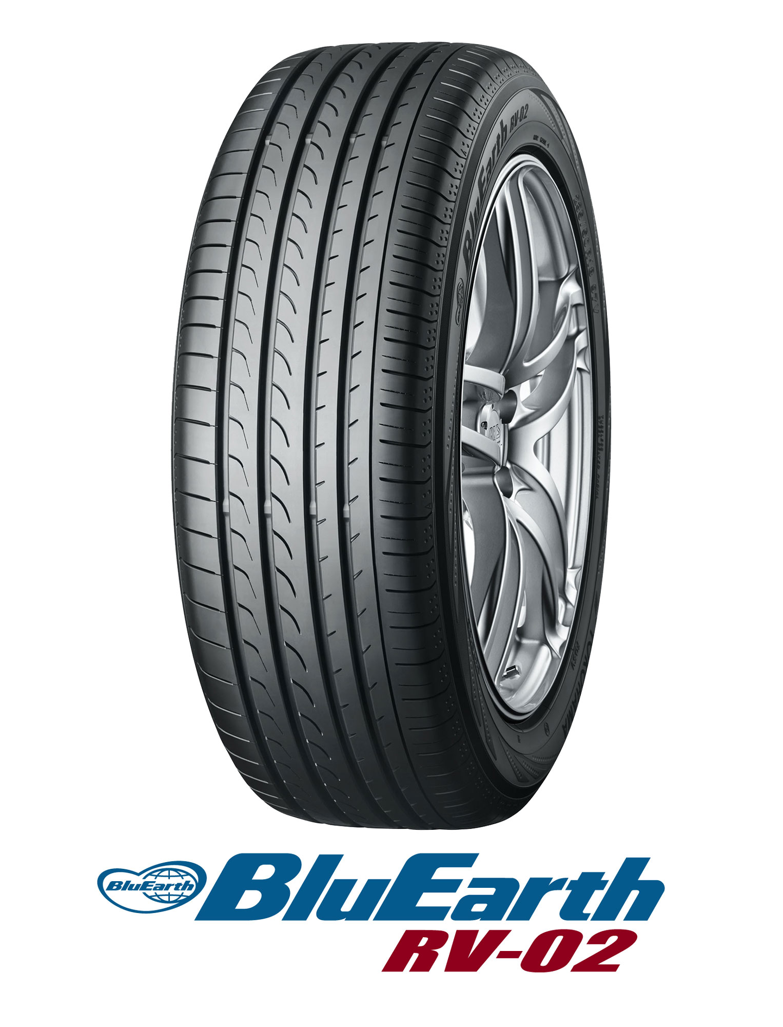

*BluEarth RV-02*